CASE STUDY 1: AI-Assisted Academic Writing

Problem Statement: Analyze how prompt engineering improves academic writing quality and productivity

TOOLS USED:

Chat Gpt:

Gemini

Claude

PROMPT:

Act as an Academic Writing Expert. Explain how prompt engineering improves academic writing quality and productivity. Discuss its benefits for content quality, clarity, grammar, research, and time management. Describe its use in assignments, reports, and research papers. Include challenges, ethical issues, best practices, examples, and a conclusion.

RESPONSE:

Introduction
Prompt engineering is the process of designing clear, specific, and structured instructions for Artificial Intelligence (AI) tools to generate accurate and relevant responses. In academic writing, prompt engineering helps students, researchers, and educators obtain high-quality content by guiding AI systems effectively. Well-designed prompts improve writing quality, increase productivity, and support various academic tasks such as assignments, reports, project documentation, and research papers.

Role of Prompt Engineering in AI-Assisted Writing
AI writing tools generate responses based on the instructions provided by users. The quality of the output largely depends on the quality of the prompt. Prompt engineering helps users communicate their requirements clearly, enabling AI systems to produce content that aligns with academic standards.
For example:
Basic Prompt:
Explain Artificial Intelligence.
Engineered Prompt:
Explain Artificial Intelligence for undergraduate Computer Science students. Include its definition, key components, advantages, applications, and future scope in approximately 500 words with academic language.
The second prompt provides context, audience, structure, and length, resulting in a more useful academic response.

Benefits of Prompt Engineering

1. Improved Content Quality
Prompt engineering enables AI tools to generate more accurate, relevant, and detailed content. Specific instructions help reduce ambiguity and ensure that the generated material addresses the intended topic comprehensively.
Benefits:
- Better topic coverage
- More relevant information
- Increased accuracy
- Enhanced depth of discussion
Example:
Instead of asking:
Write about cloud computing.
Use:
Explain cloud computing, its service models (IaaS, PaaS, SaaS), advantages, challenges, and real-world applications in business environments.

2. Enhanced Clarity and Organization
Structured prompts help AI generate logically organized content with clear headings, subheadings, and smooth transitions.
Benefits:
- Improved readability
- Logical flow of ideas
- Better presentation of arguments
- Easier understanding for readers
Example:
Discuss Blockchain Technology using the following structure: Introduction, Working Principle, Advantages, Applications, Challenges, and Conclusion.

3. Better Grammar and Language Quality
AI tools can assist in improving grammar, sentence structure, vocabulary, and academic tone when prompted appropriately.
Benefits:
- Reduced grammatical errors
- Improved sentence construction
- Consistent academic writing style
- Enhanced professionalism
Example:
Rewrite the following paragraph using formal academic language and correct grammatical errors.

4. Increased Research Efficiency
Prompt engineering helps researchers quickly gather background information, summarize literature, and identify key concepts.
Benefits:
- Faster literature review preparation
- Efficient information gathering
- Quick concept explanations
- Time-saving research support
Example:
Summarize recent developments in Quantum Computing and identify major research challenges.

5. Improved Time Management
Students and researchers often spend significant time planning, drafting, and editing documents. Prompt engineering reduces these efforts by generating structured content efficiently.
Benefits:
- Faster drafting
- Reduced editing time
- Increased productivity
- Better management of academic deadlines
Example:
Create a detailed outline for a research paper on Cybersecurity in IoT, including major sections and subsections.

Applications in Academic Writing

1. Assignments
Prompt engineering helps students create well-structured assignments by generating explanations, summaries, examples, and references.
Example Prompt:
Explain Machine Learning algorithms for a B.Tech assignment. Include supervised learning, unsupervised learning, advantages, disadvantages, and applications.

2. Laboratory Reports
Students can use prompt engineering to organize laboratory observations and findings.
Example Prompt:
Generate a laboratory report structure for a Database Management Systems experiment, including Aim, Theory, Procedure, Results, and Conclusion.

3. Project Documentation
Prompt engineering assists in preparing project proposals, system designs, technical documentation, and implementation reports.
Example Prompt:
Create project documentation for an AI-based Chatbot System, including objectives, methodology, architecture, implementation, and future enhancements.

4. Research Papers
Researchers can use prompt engineering for idea generation, literature review support, abstract drafting, methodology explanations, and proofreading.
Example Prompt:
Write a literature review on Deep Learning applications in healthcare, highlighting major studies, findings, limitations, and future research directions.

Challenges of Prompt Engineering
Despite its benefits, prompt engineering presents several challenges.

1. Ambiguous Prompts
Unclear prompts may produce irrelevant or inaccurate outputs.
Example:
Explain networking.
This prompt lacks context regarding audience, depth, and focus.

2. Dependence on Prompt Quality
The effectiveness of AI-generated content depends heavily on how well the prompt is written.

3. Inconsistent Responses
Different prompts or slight modifications may generate varying outputs, affecting consistency.

4. Limited Domain Knowledge
AI systems may occasionally provide incomplete or outdated information, requiring verification from reliable academic sources.

Ethical Issues in AI-Assisted Academic Writing

1. Academic Integrity
Excessive reliance on AI-generated content may lead to plagiarism or misrepresentation of original work.

2. Transparency
Students and researchers should disclose AI assistance when required by institutional guidelines.

3. Accuracy and Reliability
AI-generated information should always be verified through credible academic sources.

4. Bias in AI Outputs
AI models may reflect biases present in training data, potentially affecting objectivity.

5. Intellectual Property Concerns
Questions may arise regarding ownership and authorship of AI-generated content.

Best Practices for Effective Prompt Engineering

Be Specific
Clearly define the topic, scope, audience, and objectives.
Example:
Explain Big Data Analytics for final-year Computer Science students with examples from healthcare and finance.

Provide Context
Include background information to guide AI responses.
Example:
Assume the audience has basic knowledge of networking and explain Software-Defined Networking.

Specify Output Format
Request structured responses.
Example:
Present the answer under Introduction, Features, Advantages, Challenges, and Conclusion.

Define Length and Depth
Indicate word count or level of detail.
Example:
Write a 1000-word discussion on Cloud Security Challenges.

Review and Verify Outputs
Always evaluate AI-generated content for accuracy, originality, and relevance.

Examples of Effective Academic Prompts

Example 1: Assignment Writing
Explain Internet of Things (IoT) architecture, components, applications, advantages, and challenges for a B.Tech assignment.

Example 2: Research Support
Summarize recent research trends in Explainable Artificial Intelligence (XAI) and identify future research opportunities.

SCREEN SHOT:

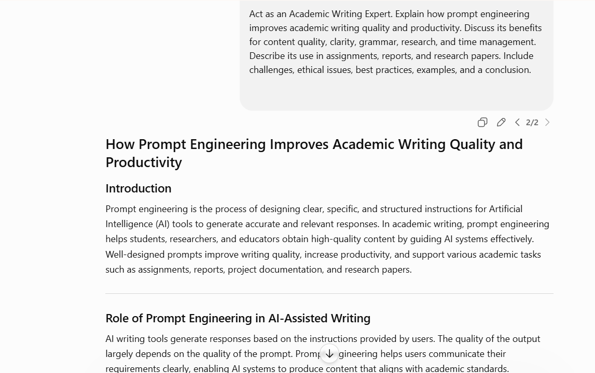
RESULT:
Prompt engineering helps AI generate accurate, clear, and well-structured academic content. It improves writing quality, grammar, and productivity while saving time on assignments, reports, and research papers. When used responsibly and with proper verification, it becomes a valuable tool for academic writing.

CASE STUDY 2: AI in Recruitment and Career Development

Problem Statement: Study the role of AI in resume generation, candidate screening, and career planning.

TOOLS USED:
CHATGPT
GEMIMI
CLAUDE

RESPONSE:

The Role of AI in Recruitment and Career Development for B.Tech Students

Introduction
Artificial Intelligence (AI) is transforming recruitment and career development by making hiring processes faster, more accurate, and more efficient. For B.Tech students, AI provides valuable support in creating resumes, finding suitable job opportunities, preparing for interviews, developing skills, and planning career paths. As organizations increasingly adopt AI-driven recruitment systems, understanding its role has become essential for engineering students seeking successful careers.

AI in Resume Creation
AI-powered tools help students create professional and optimized resumes by analyzing job descriptions and suggesting relevant skills, keywords, and formats.

Benefits
- Generates professional resume templates.
- Improves grammar and formatting.
- Suggests industry-relevant keywords.
- Increases the chances of passing Applicant Tracking Systems (ATS).

Example
A B.Tech Computer Science student applying for a Software Developer role can use AI tools to highlight programming skills, projects, internships, and certifications in a professional format.

AI in Candidate Screening
Many companies use AI systems to screen large numbers of applications. These systems evaluate resumes based on predefined criteria such as skills, education, experience, and certifications.

Benefits
- Faster candidate evaluation.
- Reduces manual screening effort.
- Identifies suitable candidates efficiently.

Example
An AI recruitment system may shortlist candidates with skills in Python, Java, and Machine Learning for an AI Engineer position.

AI in Job Matching
AI algorithms analyze candidate profiles and job requirements to recommend suitable employment opportunities.

Benefits
- Personalized job recommendations.
- Better alignment between skills and job roles.
- Increased chances of finding relevant positions.

Example
A student interested in Data Science may receive recommendations for Data Analyst, Business Intelligence, and Machine Learning roles based on their profile.

AI in Interview Preparation
AI-based interview platforms provide mock interviews, evaluate responses, and offer feedback on communication, confidence, and technical knowledge.

Benefits
- Improves interview performance.
- Builds confidence.
- Identifies areas for improvement.

Example
An AI mock interview tool can simulate technical interview questions on Data Structures and Algorithms and provide instant feedback.

AI in Skill Development
AI-powered learning platforms recommend courses, tutorials, and certifications based on individual career goals and skill gaps.

Benefits
- Personalized learning paths.
- Continuous skill enhancement.
- Improved employability.

Example
A student interested in Cybersecurity may receive recommendations for ethical hacking, network security, and cloud security courses.

AI in Career Planning
AI helps students identify career opportunities, future industry trends, and required competencies for specific professions.

Benefits
- Better career decision-making.
- Identification of emerging technologies.
- Long-term career guidance.

Example
An AI career advisor may suggest learning Artificial Intelligence and Cloud Computing due to their growing demand in the technology industry.

Benefits of AI in Recruitment and Career Development

1. Increased Efficiency
AI automates repetitive recruitment tasks and speeds up hiring processes.

2. Personalized Guidance
Students receive customized recommendations for jobs, skills, and learning resources.

3. Better Job Opportunities
AI improves matching between candidates and employers.

4. Continuous Learning Support
Students can identify and address skill gaps effectively.

5. Enhanced Interview Readiness
AI-powered feedback helps improve communication and technical performance.

Challenges of AI in Recruitment

1. Algorithm Bias
AI systems may unintentionally favor certain candidates due to biased training data.

2. Overdependence on Technology
Excessive reliance on AI may overlook human qualities such as creativity and leadership.

3. Privacy Concerns
Recruitment systems collect and process large amounts of personal data.

4. Incorrect Assessments
AI may occasionally misinterpret candidate qualifications or potential.

Ethical Considerations

Fairness
Recruitment systems should provide equal opportunities to all applicants.

Transparency
Organizations should explain how AI-based decisions are made.

Data Privacy
Candidate information must be protected and used responsibly.

Human Oversight
Final hiring decisions should involve human judgment alongside AI recommendations.

Best Practices for B.Tech Students

Create Accurate Profiles
Maintain updated resumes and professional online profiles.

Develop Relevant Skills
Learn industry-demanded technologies and certifications.

Use AI as a Support Tool
Combine AI recommendations with personal judgment and career goals.

Verify AI Suggestions
Cross-check information and opportunities recommended by AI systems.

Practice Regularly
Use AI-powered interview preparation and learning platforms to improve skills.

Examples of AI Applications

Example 1: Resume Optimization
AI suggests improvements in resume structure and keywords for a Software Developer role.

Example 2: Job Recommendation
An AI platform recommends cloud computing positions to a student with AWS certification.

Example 3: Mock Interviews
AI evaluates interview responses and provides communication improvement suggestions.

Example 4: Learning Recommendations
AI identifies skill gaps and recommends Machine Learning certification courses.
SREEN SHOT:
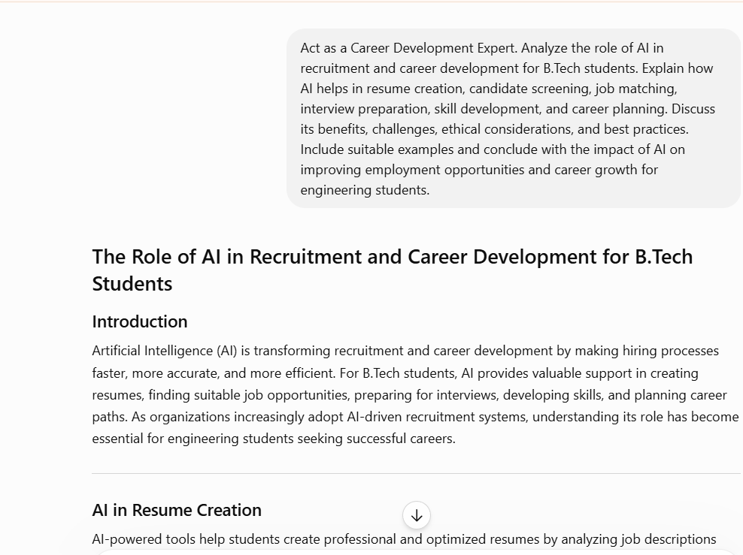

Result
AI is transforming recruitment and career development by helping students create better resumes, find suitable jobs, prepare for interviews, and develop relevant skills. It improves efficiency, personalization, and employment opportunities through intelligent recommendations and automation. When used ethically and responsibly, AI can significantly support career growth and professional success for B.Tech students.

CASE STUDY 3: AI-Powered Business Communication
Problem Statement: Analyze how AI enhances professional communication and workplace productivity
TOOLS USED:
Chatgpt
Gemini
Claude
RESPONSE:

Introduction
Artificial Intelligence (AI) is transforming business communication by improving the way organizations create, share, and manage information. AI-powered tools help professionals communicate more effectively, automate routine tasks, and increase workplace productivity. From email writing and report preparation to meeting summaries and customer interactions, AI has become an essential tool in modern business environments.

AI in Email Writing
AI assists professionals in drafting clear, professional, and grammatically correct emails. It can suggest subject lines, improve tone, and generate responses based on context.

Benefits
- Saves time in composing emails.
- Improves grammar and clarity.
- Maintains professional communication standards.

Example
An employee can use AI to draft a formal email requesting project approval from a manager.

AI in Report Preparation
AI helps create business reports by organizing information, summarizing data, and generating structured content.

Benefits
- Faster report creation.
- Improved content organization.
- Reduced manual effort.

Example
A sales manager can use AI to generate a monthly sales performance report from collected data.

AI in Meeting Summaries
AI-powered tools can record meetings, transcribe discussions, and generate concise summaries with action items.

Benefits
- Accurate documentation of discussions.
- Saves note-taking time.
- Improves follow-up actions.

Example
After a project meeting, AI automatically creates a summary highlighting decisions and assigned tasks.

AI in Customer Communication
Businesses use AI chatbots and virtual assistants to respond to customer inquiries and provide support.

Benefits
- 24/7 customer service.
- Faster response times.
- Improved customer satisfaction.

Example
An AI chatbot can answer frequently asked questions about products and services instantly.

AI in Team Collaboration
AI supports collaboration by organizing tasks, scheduling meetings, sharing updates, and managing workflows.

Benefits
- Better team coordination.
- Improved productivity.
- Efficient project management.

Example
AI tools can automatically schedule meetings based on team availability and send reminders.

Benefits of AI in Business Communication

1. Increased Productivity
AI automates repetitive communication tasks, allowing employees to focus on important work.

2. Improved Accuracy
AI reduces grammatical and formatting errors in business documents.

3. Faster Communication
Information can be generated, summarized, and shared quickly.

4. Enhanced Collaboration
Teams can work together more effectively using AI-powered tools.

5. Better Customer Service
AI enables quick and consistent responses to customer inquiries.

Challenges of AI in Business Communication

1. Dependence on Technology
Excessive reliance on AI may reduce human communication skills.

2. Contextual Errors
AI may occasionally misunderstand context and generate incorrect responses.

3. Data Privacy Risks
Sensitive business information must be protected from unauthorized access.

4. Implementation Costs
Organizations may need significant investment to adopt AI systems.

Ethical Considerations

Transparency
Organizations should disclose when AI is used in communication processes.

Data Privacy
Personal and business information must be handled securely.

Fairness
AI systems should avoid biased or discriminatory communication.

Human Oversight
Important decisions and communications should be reviewed by humans.

Best Practices

Use Clear Inputs
Provide detailed instructions to obtain accurate AI-generated outputs.

Verify Content
Review AI-generated emails, reports, and summaries before sharing.

Protect Sensitive Information
Avoid entering confidential data into unsecured AI platforms.

Combine AI with Human Judgment
Use AI as a support tool rather than a complete replacement for human communication.

Regularly Update Skills
Employees should learn how to effectively use AI communication tools.

Examples of AI Applications

Example 1: Email Drafting
AI generates a professional email requesting project updates from team members.

Example 2: Report Generation
AI creates a quarterly business performance report using sales data.

Example 3: Meeting Summary
AI converts a one-hour meeting into a concise summary with action points.

Example 4: Customer Support
An AI chatbot answers customer questions regarding product availability and delivery status.

SCREEN SHOT:

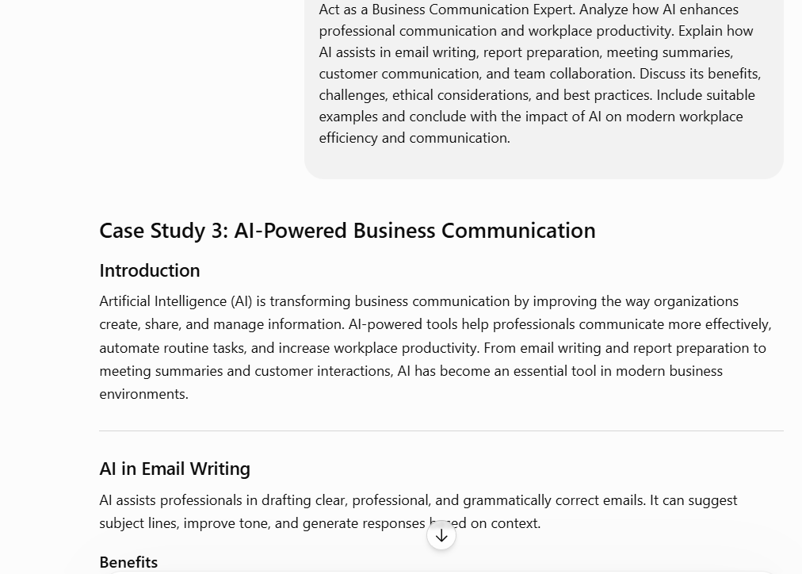

Result
AI improves business communication by helping employees write emails, prepare reports, summarize meetings, and support customer interactions. It increases productivity, accuracy, and collaboration while saving time and effort. When used responsibly, AI enhances workplace efficiency and supports effective professional communication.

CASE STUDY 4: AI Research and Knowledge Extraction

PROBLEM STATEMENT: Study how AI assists in literature review, summarization, and information retrieval.

TOOLS USED:

Chat Gpt:

Gemini
Claude

RESPONSE:

AI in Research and Knowledge Extraction

Introduction
Artificial Intelligence (AI) is transforming research and knowledge extraction by helping researchers collect, analyze, and interpret information more efficiently. AI-powered tools assist in literature reviews, summarization, information retrieval, and data analysis, enabling researchers to save time and improve the quality of their work. As research data continues to grow rapidly, AI has become an important tool for knowledge discovery and scientific advancement.

AI in Literature Review
AI helps researchers identify, collect, and organize relevant academic papers from large databases.

Benefits
- Faster literature search.
- Identification of relevant studies.
- Improved organization of research sources.

Example
A researcher studying Machine Learning can use AI tools to find and categorize hundreds of related research papers within minutes.

AI in Summarization
AI can automatically summarize lengthy research articles, reports, and documents into concise and understandable formats.

Benefits
- Saves reading time.
- Highlights key findings.
- Improves understanding of complex topics.

Example
An AI tool can summarize a 20-page research paper into a one-page overview containing objectives, methodology, and conclusions.

AI in Information Retrieval
AI-powered search systems help researchers quickly find accurate and relevant information from large datasets and digital libraries.

Benefits
- Quick access to information.
- Improved search accuracy.
- Efficient knowledge extraction.

Example
A student researching Cybersecurity can use AI search tools to locate recent studies, datasets, and technical reports related to security threats.

AI in Data Analysis
AI assists in analyzing large volumes of structured and unstructured data by identifying patterns, trends, and relationships.

Benefits
- Faster data processing.
- Improved analytical accuracy.
- Better decision-making support.

Example
Researchers can use AI algorithms to analyze healthcare data and identify factors influencing disease diagnosis.

Benefits of AI in Research

1. Improved Research Quality
AI provides comprehensive information and identifies relevant sources, leading to more detailed research outcomes.

2. Enhanced Accuracy
AI reduces manual errors in data processing and information organization.

3. Increased Efficiency
Research tasks such as searching, summarizing, and analyzing data can be completed much faster.

4. Better Time Management
Researchers spend less time on repetitive tasks and more time on critical thinking and innovation.

5. Knowledge Discover
AI helps uncover hidden patterns and relationships that may not be easily identified through traditional methods.

Challenges of AI in Research

1. Data Quality Issues
Poor-quality or biased data can affect AI-generated results.

2. Inaccurate Information
AI may occasionally provide incomplete or incorrect information.

3. Dependence on Technology
Overreliance on AI may reduce critical evaluation and independent analysis.

4. Limited Context Understanding
AI may struggle to interpret complex research contexts accurately.

Ethical Considerations

Academic Integrity
Researchers should avoid presenting AI-generated content as entirely their own work.

Transparency
The use of AI in research should be disclosed when appropriate.

Data Privacy
Sensitive research data must be protected and handled securely.

Bias and Fairness
Researchers should assess AI outputs for potential bias and ensure objective analysis.A

Best Practices

Use Reliable Sources
Verify AI-generated information using trusted academic databases and journals.

Combine AI with Human Expertise
Use AI as a support tool rather than a replacement for critical thinking.

Validate Results
Cross-check findings and interpretations before including them in research.

Protect Data
Ensure confidential research data is handled securely.

Maintain Academic Ethics
Cite sources properly and follow institutional guidelines regarding AI use.

Examples of AI Applications

Example 1: Literature Review
AI identifies and organizes relevant research papers on Artificial Intelligence in Healthcare.

Example 2: Research Summarization
AI generates concise summaries of lengthy journal articles.
SCREEN SHOT:
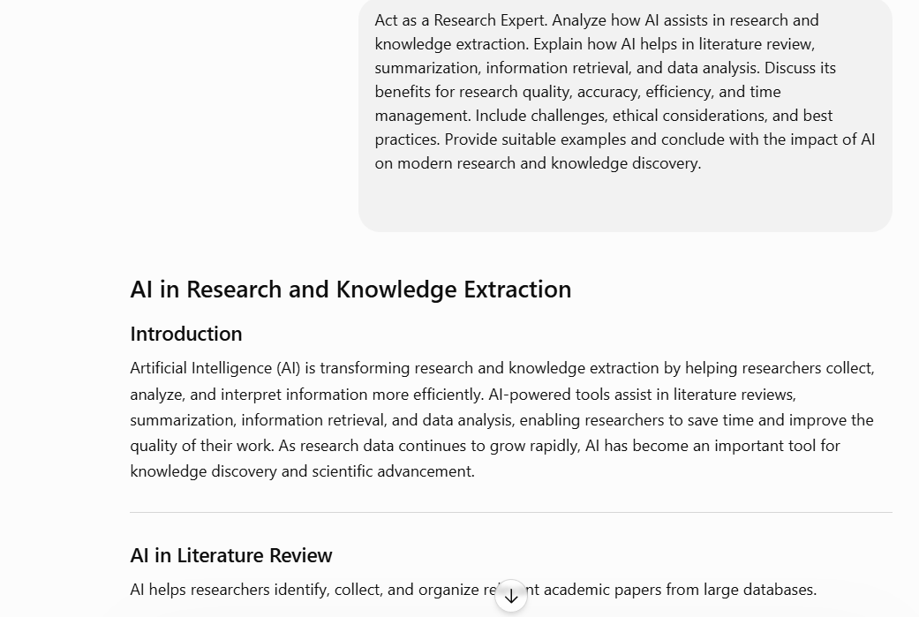

Result
AI helps researchers perform literature reviews, summarize information, retrieve relevant knowledge, and analyze data more efficiently. It improves research quality, accuracy, productivity, and time management while supporting faster knowledge discovery. When used ethically and responsibly, AI becomes a powerful tool for modern research and innovation.

CASE STUDY 5: Prompt Engineering for Productivity
PROBLEM STATEMENT: Evaluate the effectiveness of prompt engineering techniques in improving learning and professional workflows.

TOOLS USED:

Chat Gpt:

Gemini

Claude
RESPONSE:
Evaluating the Effectiveness of Prompt Engineering in Learning and Professional Workflows

Introduction
Prompt engineering is the practice of designing clear, specific, and structured instructions for AI systems to generate accurate and relevant outputs. It plays a crucial role in improving learning experiences and professional workflows by helping users obtain better results from AI tools. Effective prompt engineering enhances problem-solving, content creation, research, and decision-making while increasing productivity and efficiency.

How Prompt Engineering Enhances AI-Generated Outputs
Well-designed prompts provide clear context, objectives, and expected formats, enabling AI systems to generate high-quality responses.

Benefits
- More accurate information.
- Better organization of content.
- Reduced ambiguity.
- Improved relevance of outputs.

Example
Basic Prompt: "Explain Cloud Computing."
Effective Prompt: "Explain Cloud Computing for B.Tech students, including service models, advantages, applications, and challenges in 500 words."

Prompt Engineering for Problem-Solving
Prompt engineering helps users obtain structured solutions to complex problems by clearly defining the task and expected output.

Benefits
- Improved analytical thinking.
- Faster problem resolution.
- Better understanding of concepts.

Example
A student can use AI to solve programming problems by specifying the programming language, input requirements, and expected output.

Prompt Engineering for Content Creation
AI can generate assignments, reports, articles, presentations, and documentation more effectively when guided by detailed prompts.

Benefits
- Improved content quality.
- Better structure and clarity.
- Reduced writing effort.

Example
A project report prompt specifying headings, objectives, methodology, and conclusions produces a more organized document.

Prompt Engineering for Research
Researchers use prompt engineering to gather information, summarize literature, and identify research trends.

Benefits
- Faster literature reviews.
- Efficient information retrieval.
- Better research support.

Example
A researcher can request a summary of recent developments in Artificial Intelligence and their practical applications.

Prompt Engineering for Decision-Making
AI can support decision-making by analyzing information and presenting recommendations based on specified criteria.

Benefits
- Data-driven insights.
- Improved evaluation of alternatives.
- Faster decision processes.

Example
A business manager can ask AI to compare cloud service providers based on cost, security, and scalability.

Benefits of Prompt Engineering

1. Increased Productivity
Well-structured prompts reduce the time required to generate useful outputs.

2. Improved Accuracy
Specific instructions help AI provide more relevant and precise information.

3. Enhanced Efficiency
Users can complete tasks faster with less manual effort.

4. Better Time Management
Prompt engineering automates repetitive tasks and streamlines workflows.

5. Improved Learning Experience
Students receive customized explanations and study materials.

Challenges of Prompt Engineering

1. Ambiguous Prompts
Unclear instructions may result in inaccurate or irrelevant outputs.

2. Dependence on User Skills
The quality of AI responses depends on the user's ability to create effective prompts.

3. Inconsistent Results
Different prompt structures may produce varying outputs.

4. Limited Context Understanding
AI may misinterpret complex requirements if prompts lack sufficient detail.

Ethical Considerations

Academic Integrity
Users should avoid presenting AI-generated work as entirely their own.

Transparency
The use of AI assistance should be disclosed when required.

Data Privacy
Sensitive information should not be shared with AI systems without proper safeguards.

Bias and Fairness
AI-generated outputs should be reviewed for potential bias and inaccuracies.

Best Practices for Effective Prompt Engineering

Be Specific
Clearly define the objective, audience, and expected outcome.

Provide Context
Include relevant background information.

Specify Output Format
Request structured responses with headings, tables, or summaries when needed.

Define Scope and Length
Mention the required depth and word count.

Review and Refine
Evaluate outputs and improve prompts iteratively for better results.

Examples of Effective Prompts

Example 1: Learning
"Explain Machine Learning for third-year B.Tech students with examples, advantages, and applications."

Example 2: Content Creation
"Write a project report on Blockchain Technology with Introduction, Methodology, Results, and Conclusion."

Example 3: Research
"Summarize recent research trends in Quantum Computing and identify future challenges."

Example 4: Decision-Making
"Compare AWS, Azure, and Google Cloud based on pricing, features, and security.

SCREEN SHOT:

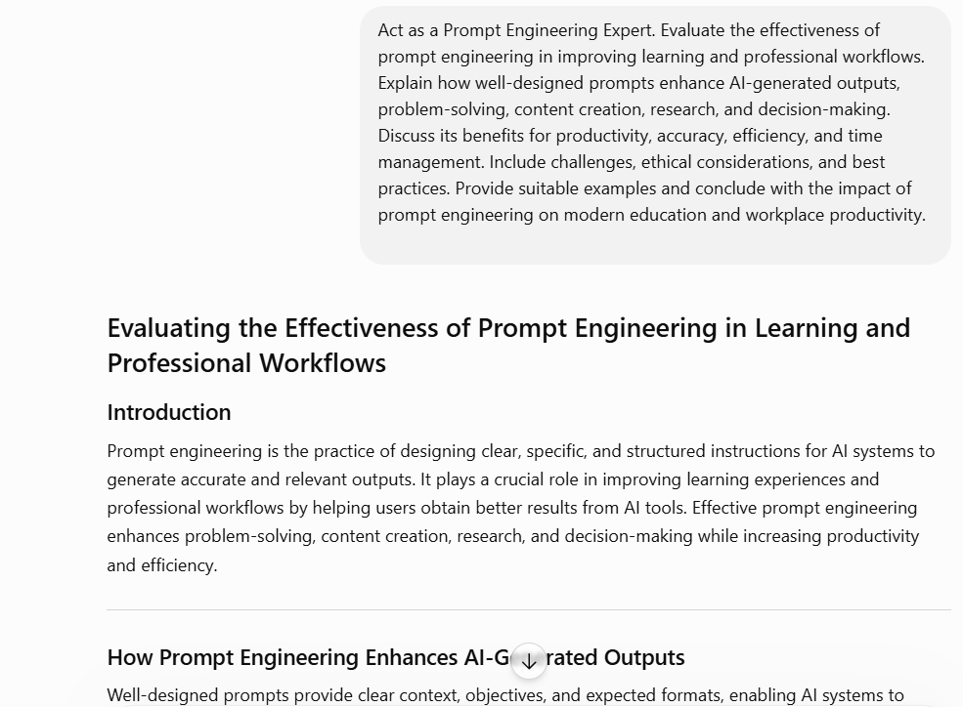

Result:
Prompt engineering improves AI performance by generating accurate, relevant, and well-structured outputs for learning and professional tasks. It enhances productivity, efficiency, problem-solving, research, and decision-making while saving time and effort. When used responsibly, prompt engineering becomes a valuable skill for modern education and workplace productivity.

